IPS Employment Support Team Leader
Job Description and Person Specification
IPS Employment Support Team Leader

Hours | Full Time (37 hours per week)
Leeds Mind Grade | Grade 4
Contract | Permanent
Location | De Lacey House, Kirkstall Abbey Road, Kirkstall, Leeds, LS5 3HS with occasional travel across Leeds and surrounding areas
Annual Leave | 28 days a year plus 8 Statutory holidays, rising to 31 days after 3 years
Pension | 3% employer contribution, 5% employee contribution, enhanced by salary exchange
Probationary Period | 6 months
Reporting to | Economic Inclusion Services Manager
DBS Check Level | Enhanced

Introduction

We have faith and optimism in the people who access our services and so delivery is built around their needs. We support the people of Leeds West Yorkshire to discover their own resources to ‘recover’ from periods of poor mental health, and to live life independently with their mental health difficulties. Our values of Being Open, Supportive, Brave, Connected and Resourceful are pivotal to the work we do.

This role sits within Leeds Mind’s employment and economic inclusion services and is central to the delivery of high-quality Individual Placement and Support (IPS). The post holder will lead a team of Employment Specialists, ensuring the service operates with strong IPS fidelity, achieves positive employment outcomes, and contributes to the wider recovery goals of people experiencing mental health difficulties.

Belonging at Leeds Mind

Leeds Mind is committed to creating an inclusive environment – equity, diversity and inclusion are at the heart of everything that we do.
We are committed to ensuring that our colleagues, volunteers and people who access our services feel a sense of belonging at Leeds Mind that gives them the confidence to share their unique perspectives and experience.
By creating an inclusive environment that fosters belonging, we aspire to attract colleagues and volunteers who offer diversity of experience and thought. We believe this will ultimately improve the service we provide as well as the employee and volunteer experience.
To find out more about how we are developing this you can click here.

Purpose of the role
The IPS Employment Support Team Leader will manage, develop and inspire a team of Employment Specialists delivering the Individual Placement and Support (IPS) model. The role is responsible for ensuring high-quality, recovery-focused delivery that meets IPS fidelity standards and achieves sustained paid employment outcomes for people with mental health support needs.
The post holder will provide leadership, supervision, coaching and performance management to the team, and work collaboratively with clinical teams, employers, commissioners and wider stakeholders to ensure the service delivers positive, person-centred outcomes aligned with both IPS & Leeds Mind’s values.

Team Structure
The IPS Employment Support Team Leader reports to the Economic Inclusion Services Manager and line manages a team of IPS Employment Specialists. The role works closely with other Team Leaders, clinical partners, peer support roles, and other Leeds Mind services as part of a multidisciplinary approach to recovery and inclusion. See diagram below:-
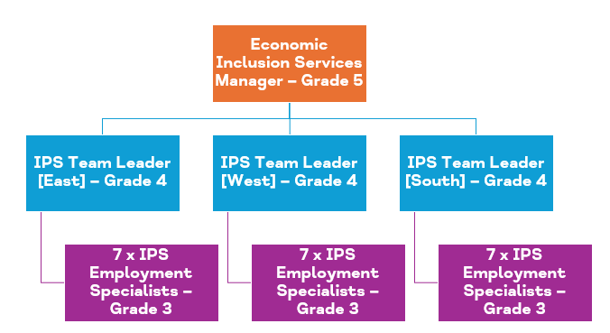

Main Tasks and Responsibilities
- Lead and manage an IPS team to deliver an effective, high‑quality service, maintaining a clear focus on fidelity, performance and continuous improvement.
- Oversee a comprehensive quality assurance framework, including regular scored fidelity reviews delivered with IPS Grow partners and structured internal self‑review processes.
- Lead the team through external and internal fidelity reviews, ensuring findings are translated into clear improvement actions, strengthened practice and sustained adherence to IPS standards.
- Line manages, supervise and coach Employment Specialists, providing regular solution-focused supervision and caseload management.
- Monitor individual and team performance against employment outcomes, supporting staff to meet and exceed targets.
- Create a positive team culture of continuous improvement, reflective practice and learning.
- Identify training and development needs and support the design and delivery of in-house training and peer learning.
- Lead employer engagement and job development activity, ensuring Employment Specialists spend sufficient time building meaningful employer relationships.
- Work collaboratively with clinical teams, external agencies and training providers to support holistic recovery and employment outcomes.
- Ensure robust quality assurance, including service user feedback, co-production and continuous service development.
- Contribute to service monitoring, reporting, budget management, marketing and promotion, including sharing employment recovery stories.

Organisation
- Participate in 1:1s, performance and development, including Leeds Mind compulsory training programme
- Attend and participate in service/team meetings
- Work within the framework of Leeds Mind’s policies and procedures
- Promote the values, behaviours and ethos of Leeds Mind
- Respond and report on safeguarding concerns in line with the Leeds Mind safeguarding policy and procedure
- Undertake any other reasonable duties as and when required

Person Specification
 | Essential | Desirable
Knowledge/  Qualifications | - Educated to degree level or equivalent relevant experience.  - Knowledge of mental health, disability and employment-related legislation and policy.  - Understanding of supported employment and recovery-focused practice. | - IPS training or qualification.  - Level 3 Diploma in Employability Services or Advice & Guidance (or equivalent).
Skills/Ability | - Strong leadership and people management skills.  - Excellent communication, listening and motivational skills.  - Ability to build trusting, effective relationships with service users, staff, employers and partners.  - Ability to work independently, use initiative and manage competing priorities.  - Strong IT skills, including Microsoft Office applications | - Experience of designing or delivering training.
Experience | - Demonstrated experience working with people with mental health support needs or similar.  - Demonstrated experience working in employment or employability related services.  - Experience of supervising, managing or mentoring staff.  - Proven experience of achieving outcomes and working to targets.  - Experience of managing change and supporting service development | - Experience of delivering IPS services.  - Experience in leading and/or taking part in a fidelity review or similar quality assurance checks.  - Experience of partnership working within health, social care or voluntary sector settings.
Behavioural | - Motivated, confident and resilient.  - Non-judgemental, empathetic and committed to recovery-focused practice.  - Lives our values every day – Being Open, Supportive, Brave, Connected, and Resourceful.  - Open to change and able to work flexibly in line with the needs of the service/organisation.  - Commitment to working in partnership with service users, management, and staff.  - Understanding of the challenges faced by people experiencing mental health difficulties.  - Demonstrate a commitment to equality and diversity in the workplace.  - Commitment to safeguarding clients and others you may come into contact with as part of your role. | - Lived experience of mental health difficulties.

