Plan Your Day
Seminar and Wellbeing Activity Guide
Leeds Mindful Employer Network Conference

Use this guide to choose your sessions and plan your day at #LMEC26

How to use this guide

You’ve been sent a Booking Form asking you to choose your sessions and wellbeing activities in advance.
This guide gives a short overview of each seminar and wellbeing activity to help you decide what’s most relevant for you.
Use the timetable on page 12 to circle your choices before submitting your Booking Form so you can keep track of your selections and plan your day. Session titles in the timetable are shortened — see the guide for full details.
The morning seminar programme is repeated in the afternoon, giving you the opportunity to attend a range of sessions.

Seminars:

Nailing the basics: Everyday Foundations for Workplace Wellbeing
Leeds Mind
Discover the practical, low-cost habits that make the biggest difference to everyday wellbeing and build upon what you’re already doing.
Who it’s for:
Everyone passionate about creating healthy workplaces, may be particularly interesting for People Team Leaders and Advisors and Small Business Owners/Directors

Connection That Works: Supporting People and Productivity in Remote and Hybrid Teams
Thrive Law
Employers will learn how building meaningful connection at work improves wellbeing, strengthens team performance, and helps organisations meet their people and legal responsibilities.
Who it’s for:
Leaders, Managers, People teams, MHFAs, Wellbeing Leads, Company Directors, Business Owners

Financial Wellbeing at Work - how employers can make a real difference
MoneyBuddies and the Money and Pensions Service
Help your people feel supported, understood and confident when money worries arise — your workplace can make the difference.
Who it’s for:
Leaders, Managers, People teams, MHFAs, Wellbeing Leads, Company Directors Business Owners

Building an Anti-Racist Workplace Culture
Leeds Community Healthcare NHS Trust
This workshop explores the value of an anti-racist workplace and the core elements required to achieve it.
Who it’s for:
Everyone interested and invested in anti-racist workplace cultures. May be particularly relevant for Senior Leaders, Company Directors and Business Owners

Neurodiversity at Work: Adjustments that Make a Difference
ThinkND: Inclusive Solutions and the Second Loop
From Uncertainty to Action: Practical advice to help you confidently identify and implement adjustments that work for people and for the business.
Who it’s for:
Leaders, Managers, People Teams, MHFAs, Wellbeing Leads, Company Directors and Business Owners

Organisational Transformations – Supporting Mental Health through Change
Sprout Coaching and Mind (national)
Providing strategic leadership through change, redundancies and restructures by creating clarity, embedding psychological safety and protecting mental health — all to strengthen performance and business outcomes.
Who it’s for:
Senior Leaders, People Teams and Managers

Making Wellbeing Land in male dominant workforces
Panel
Explore why wellbeing often misses the mark in male-dominated workplaces — and what actually makes it resonate in the real world.
Who it’s for:
Leaders, Managers, People Teams, MHFAs, Wellbeing Leads, Company Directors and Business Owners

Menopause & Perimenopause: What Every Workplace Needs to Get Right
Leeds and York Partnership NHS Foundation Trust
Breaking the stigma around menopause and the workplace – practical tools and suggestions to make a difference for your workforce.
Who it’s for:
Leaders, Managers, People Teams, MHFAs, Wellbeing Leads, Company Directors and Business Owners

Making Work Work for Parents & Working Carers: What Employers Need to Know
Power of the Parent and Carers Leeds
A practical guide to supporting parents and carers at work — including how to identify hidden carers, respond to changing and sometimes unpredictable needs, and connect with free local support, so your people and your organisation can thrive.
Who it’s for:
Leaders, Managers, People Teams, MHFAs, Wellbeing Leads, Company Directors and Business Owners

Recovery-Friendly Workplaces: Alcohol and Drugs
Forward Leeds
‘It’s not the drugs it’s the pain’ - Supporting employees with substance dependency like any other health condition. Reducing stigma and normalising help-seeking behaviour through confidential, open, trusted, compassionate support routes that protect staff wellbeing and foster a culture of inclusion.
Who it’s for:
Leaders, Managers, People Teams, MHFAs, Wellbeing Leads, Company Directors and Business Owners

From Network Member to Meaningful Action: What Actually Changes Workplaces for the Better
PHIRST Elevate (research team at the University of Edinburgh and Leeds Autism Services)
Unpicking evaluation findings from the NIHR PHIRST Evaluation of the Leeds Mindful Employer Network, this seminar will provide clarity on the support the Network provides. Learn how to get the most out of the Network and how Network membership can be translated into action.
Who it’s for:
Leaders, Managers, People Teams, MHFAs, Wellbeing Leads, Company Directors and Business Owners, Network Members and Non-Network Members

Prioritising Mental Wellbeing in Today’s Working World – Where Pressure Won’t Stop
Leeds Beckett University, Carnegie School of Sport
Explore how creating trustworthy environments can enhance employee confidence and wellbeing through ongoing pressure and change.
Who it’s for:
Leaders and Managers looking to build resilient teams

AI, Work and Wellbeing: What Comes Next
Closing Panel, including CEO of Mind, Dr. Sarah Hughes
As AI rapidly becomes part of the everyday working environment, it is transforming how people experience their professional and personal lives.
This closing panel brings together the day’s insights to examine what the rise of AI means for wellbeing in the workplace.
Who it’s for:
Everyone! No need to book this seminar as all delegates can attend to close out the day.

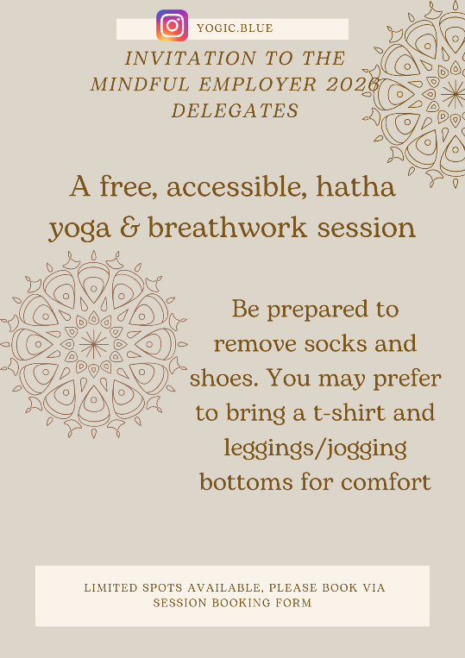
Wellbeing Activities:
Morning Hatha Yoga and Breathwork with Yogic Blue
35 minutes of gentle hatha yoga to get you ready for the day ahead.
Starting at 8.35am in the upstairs dance studio.
Secure your place via the Booking Form.

Lunchtime activities:
Singing for Wellbeing with Sharon Stacey Voice
This is an interactive 35-minute workshop designed to be welcoming and accessible to everyone (no singing experience is needed). The session focuses on creating a relaxed, supportive space where delegates can connect with their voice and experience the positive effects of singing together. The workshop includes:
- A short introduction to the science behind singing and wellbeing, exploring how singing can reduce stress, boost mood, support breathing, and encourage connection with other delegates.
- Gentle physical and vocal warm-ups to help delegates relax and feel comfortable using their voice
- Simple, inclusive group singing activities that are easy to join in with and focused on enjoyment rather than performance
- A reflective closing moment, giving delegates space to notice how they feel after singing and consider how they might use this tool in everyday life.
Secure your place via the Booking Form.

Wellbeing Walk with Active Leeds
Join Neil and Ross from Leeds City Council’s Active Leeds team on a 30-minute energising wellbeing walk around the grounds of Beckett Park. Walk off the lunch and get set for an afternoon of serious Leeds Mindful Employer Network engagement.
Register your interest via the Booking Form.

1:1 Health Check ins with Active Leeds
Take advantage of a 15-minute free health and wellbeing check in with Lou or Tom from Active Leeds. They will listen and support with a friendly and knowledgeable ear.
6 Check in appointments available. Secure your slot via the Booking Form.

Neurodiversity 10-minute Individual Check-in with Think:ND Inclusive Solutions
Feel free to book a Check-In with Kate if:
- You’re recently diagnosed and want to understand what your neurodivergent profile means for you
- You are unsure whether to share your neurodivergence with your employer – whether you’re diagnosed or self-identify
- You do not know what adjustments to ask for, or if they are ‘reasonable’
- You want to know what options for support might be available for you
5 Check in appointments available. Secure your slot via the Booking Form.

Lunchtime art activity with Arts and Minds
Take a moment for yourself during the conference with this relaxed, drop-in art activity facilitated by Sarah. No artistic experience needed, just come as you are.
Using simple, low-mess materials (origami and reverse colouring), this session offers a chance to pause, reset and enjoy a bit of creativity over your lunch. You’re welcome to bring your lunch with you and take part at your own pace.
Stay for as little or as long as you like (minimum 20 minutes recommended). If the room is full, nearby seating is available while you wait. You’ll also leave with an art pack to take away, something you can use again yourself or try out with your team back in the workplace.
Register your interest via the Booking Form. Last arrival 12.55.

Lego Lunch with Joy Junction
The Leeds Mindful Employer Network is about community, and there’s no better way to connect to that community than through this year’s Conference.
During lunch, why not join a relaxed, fun, and creative session playing with Lego. This activity is being delivered by Gary, a Leeds lad and Founder at Joy Junction.
There’ll be no instructions and no rules, just fun, food, and lots of small plastic bricks to build to your heart’s content. You can do this solo if you like, but for the best experience you might leave knowing someone new.
Register your interest via the Booking Form.

10-minute coaching/advice session for Leaders with Sprout Coaching
Book a free 10-minute coaching/advice session designed to help you take clear next steps towards leading in a way that supports both wellbeing and business performance - because you can’t have one without the other.
Bianca, founder of Sprout Coaching, has experienced first-hand the impact of highly toxic workplace cultures. That’s why she’s passionate about helping organisations build positive, inclusive environments where leaders create genuine connection, understand their people, and enable them to thrive. These focused sessions are a rare opportunity to get tailored insight on your real-world leadership challenges.
5 Coaching appointments available. Secure your slot via the Booking Form.

10-minute coaching session with Neurodivergent Leadership Coach from The Second Loop
Take advantage of a free coaching session with Jane, neurodivergent leadership coach, consultant, and facilitator. Jane believes many of the challenges individuals and organisations face during change and growth stem from invisible or unchallenged assumptions. Real change begins when we learn to see things differently.
Jane is the founder of The Second Loop, a coaching, training and consultancy organisation that supports individuals and organisations to navigate change thoughtfully and build more sustainable, inclusive working cultures. This work is informed by neurodivergent perspectives, and Jane specialises in supporting neurodivergent leaders to use their insight and experience to transform their organisations’ story.
Are you:
- a senior leader or HR professional thinking about how to evolve your organisational culture?
- an individual looking to think more clearly about a complex challenge or transition?
- a neurodivergent professional wanting to develop leadership approaches that are effective and sustainable?
If so, book a free bite-sized coaching sessions during the conference. Bring a strategic challenge, a complex situation, or something unresolved—and use the session to find clearer, more inclusive and enduring way forward.
5 Coaching Sessions available. Secure your slot via the Booking Form.

Your Timetable
Circle the sessions you plan to attend before submitting your form.
You can also note any wellbeing activities — some require booking (limited spaces), while others are drop-in.

